Lab 1

12pm-2pm

Calvin Liu

804182525

Darin Minamoto

704140102

**Objective:**

For the first project we wanted to test the use of an FPGA in making a sequencer, which can perform add or multiply instructions using registers as operands. The result is then stored in a register file. We also wanted to inspect the difference between combinational logic and sequential logic through code. For this lab we worked with a new language called Verilog and these exercises were conducted in order to help understand this language.

The UART a piece of hardware which can send the input we provide in our code to the FPGA and then have the output appear on the screen using the USB driver and a USB cable. The following diagram shows a low level depiction of the hardware.

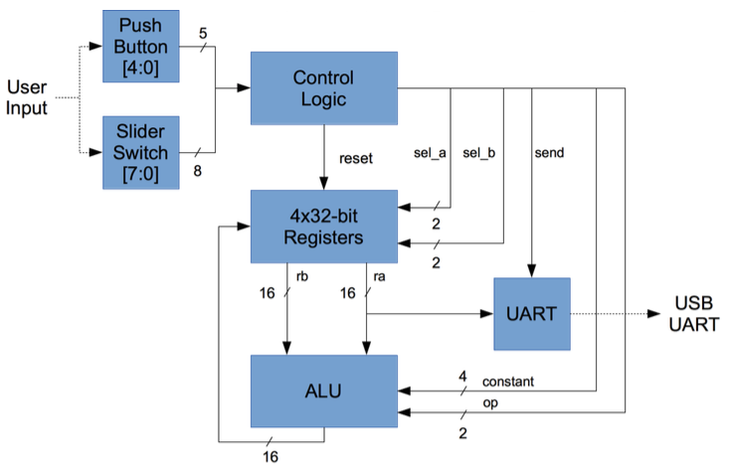

**Contributions:**

For this lab, we worked on an equal amount when programming on the computer and following the lab manual in using the FPGA. Setting up the module and making the test bench was done together along with using the FPGA equally. The lab was written together while mostly Calvin provided the pictures, but the Xilinx screenshots were taken in the lab and sent to both of us. The questions were answered together as well while we did it during lab and outside of lab.

**Set up:**

To program the FPGA we used Xilinx to load the module and create a simulation.

**Instructions:**

To operate the sequencer, the user enters instructions using the switches and the push buttons on the FPGA. An up switch signifies a binary input of 1 while a down switch represents a binary input of 0. The middle button out of the 5 provided was used to send the input to the registers and the right button was used to clear all the registers to 0. The input was then sent to the computer via a usb wire and the output was seen through the use of putty to connect to a port.

**Commands:**

The sequencer accepted the following commands: PUSH, ADD, MULT, and SEND.

Each command had its own bitstream input that was based on the command.

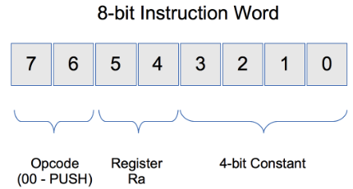

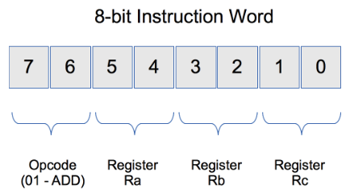

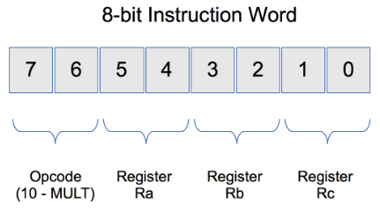

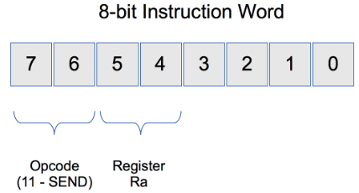

These 8 bit encoding schemes relates to the 8 switches on the FPGA.

**Exercise:**

For lab 1 we wanted to do an exercise with the FPGA.

Doing this code by hand, the expected input is supposed to be register0 = 0040, register1 = 0003, register2 = 00C0, and register3 = 0100.

|  |  |
| --- | --- |
| **Command** | **Binary Input** |
| **PUSH R0 0x4** | **00 00 0100** |
| **PUSH R0 0x0** | **00 00 0000** |
| **PUSH R1 0x3** | **00 01 0011** |
| **MULT R0 R1 R2** | **10 00 0110** |
| **ADD R2 R0 R3** | **01 10 0011** |
| **SEND R0** | **11 00 XXXX** |
| **SEND R1** | **11 01 XXXX** |
| **SEND R2** | **11 10 XXXX** |
| **SEND R3** | **11 11 XXXX** |

When running the simulation through the use of the FPGA, the following output is shown confirming our answer.

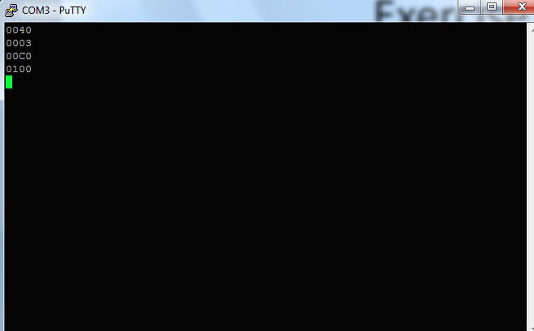

**nexys3.v**

// ================================================================

// 763Hz timing signal for clock enable

// ================================================================

assign clk_dv_inc = clk_dv + 1;

always @ (posedge clk)

if (rst)

begin

clk_dv <= 0;

clk_en <= 1'b0;

clk_en_d <= 1'b0;

end

else

begin

clk_dv <= clk_dv_inc[16:0];

clk_en <= clk_dv_inc[17];

clk_en_d <= clk_en;

end

// =================================================================

// Instruction Stepping Control

// =================================================================

always @ (posedge clk)

if (rst)

begin

inst_wd[7:0] <= 0;

step_d[2:0] <= 0;

end

else if (clk_en)

begin

inst_wd[7:0] <= sw[7:0];

step_d[2:0] <= {btnS, step_d[2:1]};

end

always @ (posedge clk)

if (rst)

inst_vld <= 1'b0;

else

inst_vld <= ~step_d[0] & step_d[1] & clk_en_d;

always @ (posedge clk)

if (rst)

inst_cnt <= 0;

else if (inst_vld)

inst_cnt <= inst_cnt + 1;

assign led[7:0] = inst_cnt[7:0];

**seq_rf.v:**

module seq_rf (/*AUTOARG*/

// Outputs

o_data_a, o_data_b,

// Inputs

i_sel_a, i_sel_b, i_wstb, i_wdata, i_wsel, clk, rst

);

`include "seq_definitions.v"

output [alu_width-1:0] o_data_a;

output [alu_width-1:0] o_data_b;

input [seq_rn_width-1:0] i_sel_a;

input [seq_rn_width-1:0] i_sel_b;

input i_wstb;

input [alu_width-1:0] i_wdata;

input [seq_rn_width-1:0] i_wsel;

input clk;

input rst;

reg [alu_width-1:0] rf [0:seq_num_regs-1];

integer i;

always @ (posedge clk)

if (rst)

begin

for (i=0;i<seq_num_regs;i=i+1)

rf[i] <= 0;

end

else if (i_wstb)

rf[i_wsel] <= i_wdata;

assign o_data_a = rf[i_sel_a];

assign o_data_b = rf[i_sel_b];

endmodule // seq_rf

**Fibonacci code:**

The Fibonacci code we came up with was modeled on the sample code that was left there. The Fibonacci code we did has been highlighted below that produced the first 10 digits of the Fibonacci sequence (tb.v):

initial

begin

//$shm_open ("dump", , ,1);

//$shm_probe (tb, "ASTF");

clk = 0;

btnR = 1;

btnS = 0;

#1000 btnR = 0;

#1500000;

tskRunPUSH(0,1);

tskRunSEND(0);

tskRunPUSH(1,1);

tskRunSEND(1);

tskRunADD(0,1,2); //Reg2 = 2

tskRunSEND(2);

tskRunADD(2,1,0); //Reg0 = 3

tskRunSEND(0);

tskRunADD(0,2,1); //Reg1 = 5

tskRunSEND(1);

tskRunADD(0,1,2); //Reg2 = 8

tskRunSEND(2);

tskRunADD(1,2,0); //Reg0 = 13

tskRunSEND(0);

tskRunADD(2,0,1); //Reg1 = 21

tskRunSEND(1);

tskRunADD(0,1,2); //Reg2 = 34

tskRunSEND(2);

tskRunADD(1,2,0); //Reg0 = 55

tskRunSEND(0);

tskRunADD(2,0,1); //Reg1 = 89

tskRunSEND(1);

tskRunADD(0,1,2); //Reg2 = 144

tskRunSEND(2);

#1000;

$finish;

end

Sample Output:

45939875 UART0 Received byte 0d (

)

46501000 ... Running instruction 01000110

49808405 ... instruction 01000110 executed

49808405 ... led output changed to 00001011

51001000 ... Running instruction 11100000

55051285 ... instruction 11100000 executed

55051285 ... led output changed to 00001100

55059815 UART0 Received byte 30 (0)

55070835 UART0 Received byte 30 (0)

55081855 UART0 Received byte 30 (0)

55092875 UART0 Received byte 38 (8)

55103895 UART0 Received byte 0a (

)

55114915 UART0 Received byte 0d (

)

55501000 ... Running instruction 01011000

58983445 ... instruction 01011000 executed

58983445 ... led output changed to 00001101

60001000 ... Running instruction 11000000

62915605 ... instruction 11000000 executed

62915605 ... led output changed to 00001110

62924135 UART0 Received byte 30 (0)

62935155 UART0 Received byte 30 (0)

62946175 UART0 Received byte 30 (0)

62957195 UART0 Received byte 44 (D)

62968215 UART0 Received byte 0a (

)

**Exercise Questions:**

**Clock Enable:**

1) clk_en is a signal that is triggered by clk_dv. Clk_dv is a 17 bit counter that counts upwards and when it overflows, the singal triggers clk_en to be 1. This resembles a clock that produces a period of 217 outputs per second.

2) The period turns out to be 1.311ms. We measured then the clk_en periodicity for one full cycle from when the signal was a high and then went back to a high again.

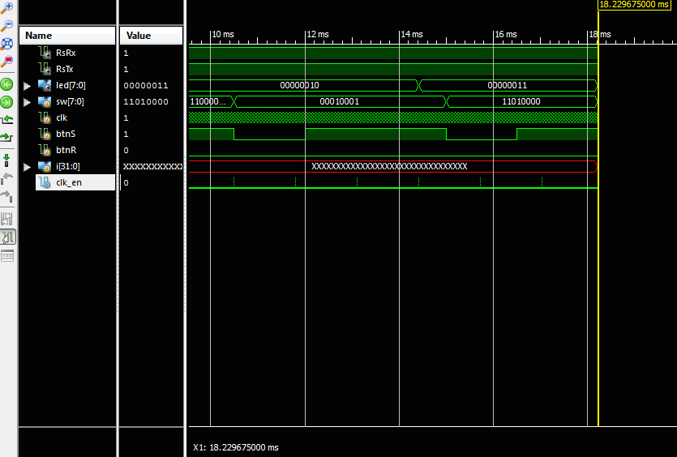

As seen by the diagram, there are multiple high points within the clk_en signal. Zooming in these turn out to be when clk_en goes from high and back to low.

3)The value of the clk_dv signal is low or 0 since all the bits have been reset.

4) 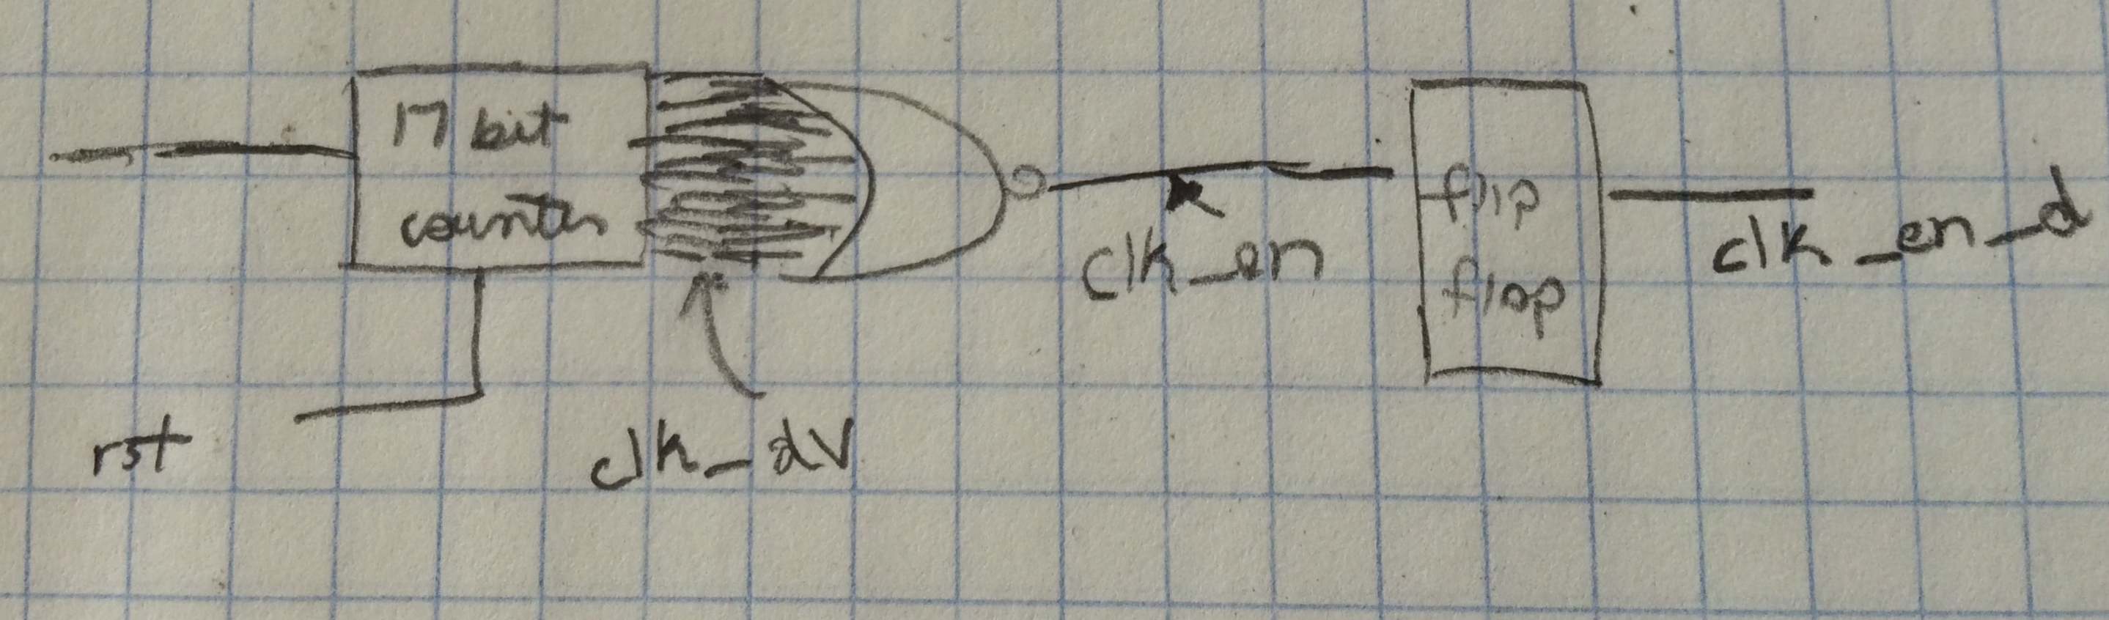

**Instruction Valid:**

2) 5.2439 ms

3) Even though clk_en and clk_en_d have the same value, the clk_en_d has to execute later and thus the clock cycle has to be delayed. It has to be done later because the step_d has to be executed first. The purpose of the clk_en_d signal is to make sure the step changes in a synchronized way because when clk_en_d changes, so does the value of step.

4)

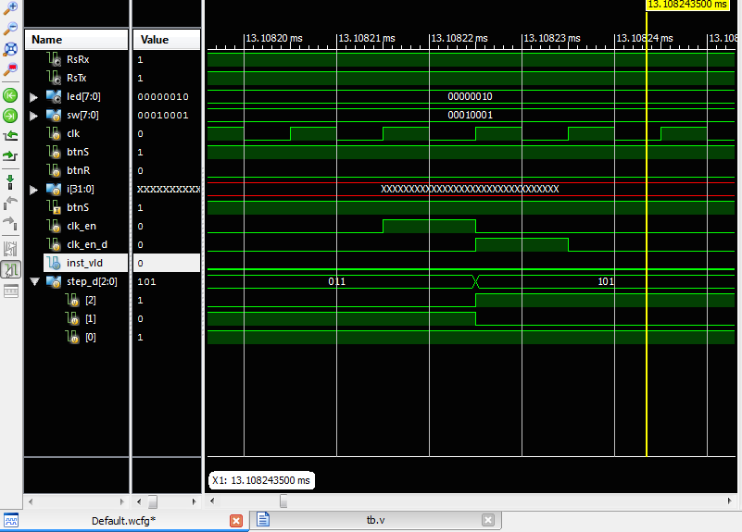

5) 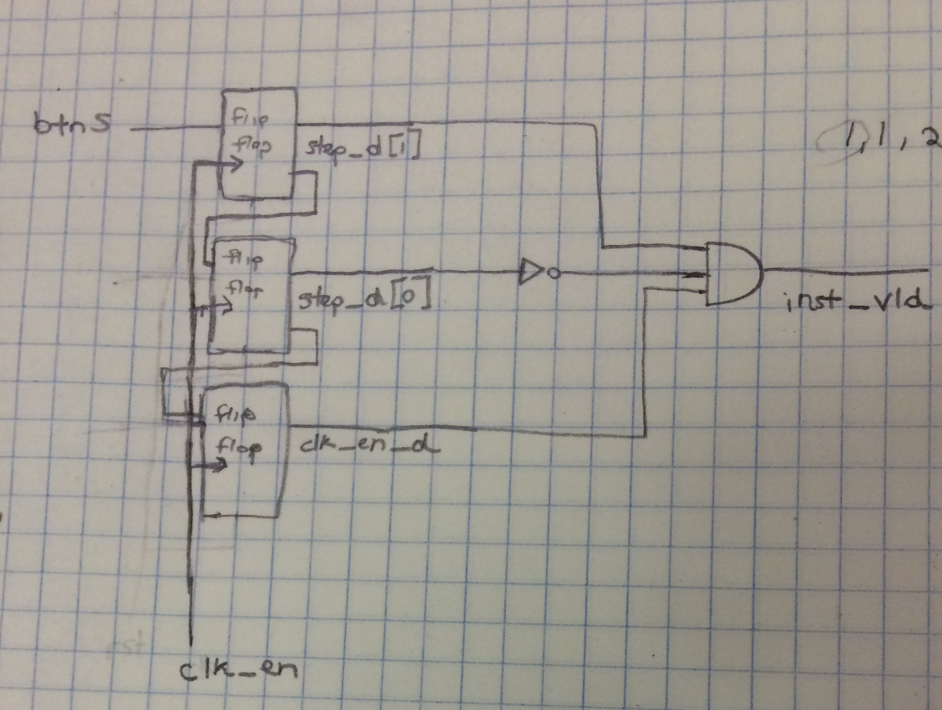

**Register File:**

1) If the rst is set to 1, the for loop goes through each register and sets it to 0. If the rst is not enabled, then the register file specified by 2 bits, represented by i_wsel takes the data of i_wdata. Then the output data is set for whenever the user wants the data from the rf (register file).

2)

rf[i_wsel] <= i_wdata

is the line where a register is written a non-zero value.

It is sequential because it is located in the always block

3)

assign o_data_a = rf[i_sel_a];

assign o_data_b = rf[i_sel_b];

This type of logic is combinatorial because the data is just fetched from the register when necessary. If we were to manually implement this then we would use a multiplexer to choose which register needs to be read out.

4)

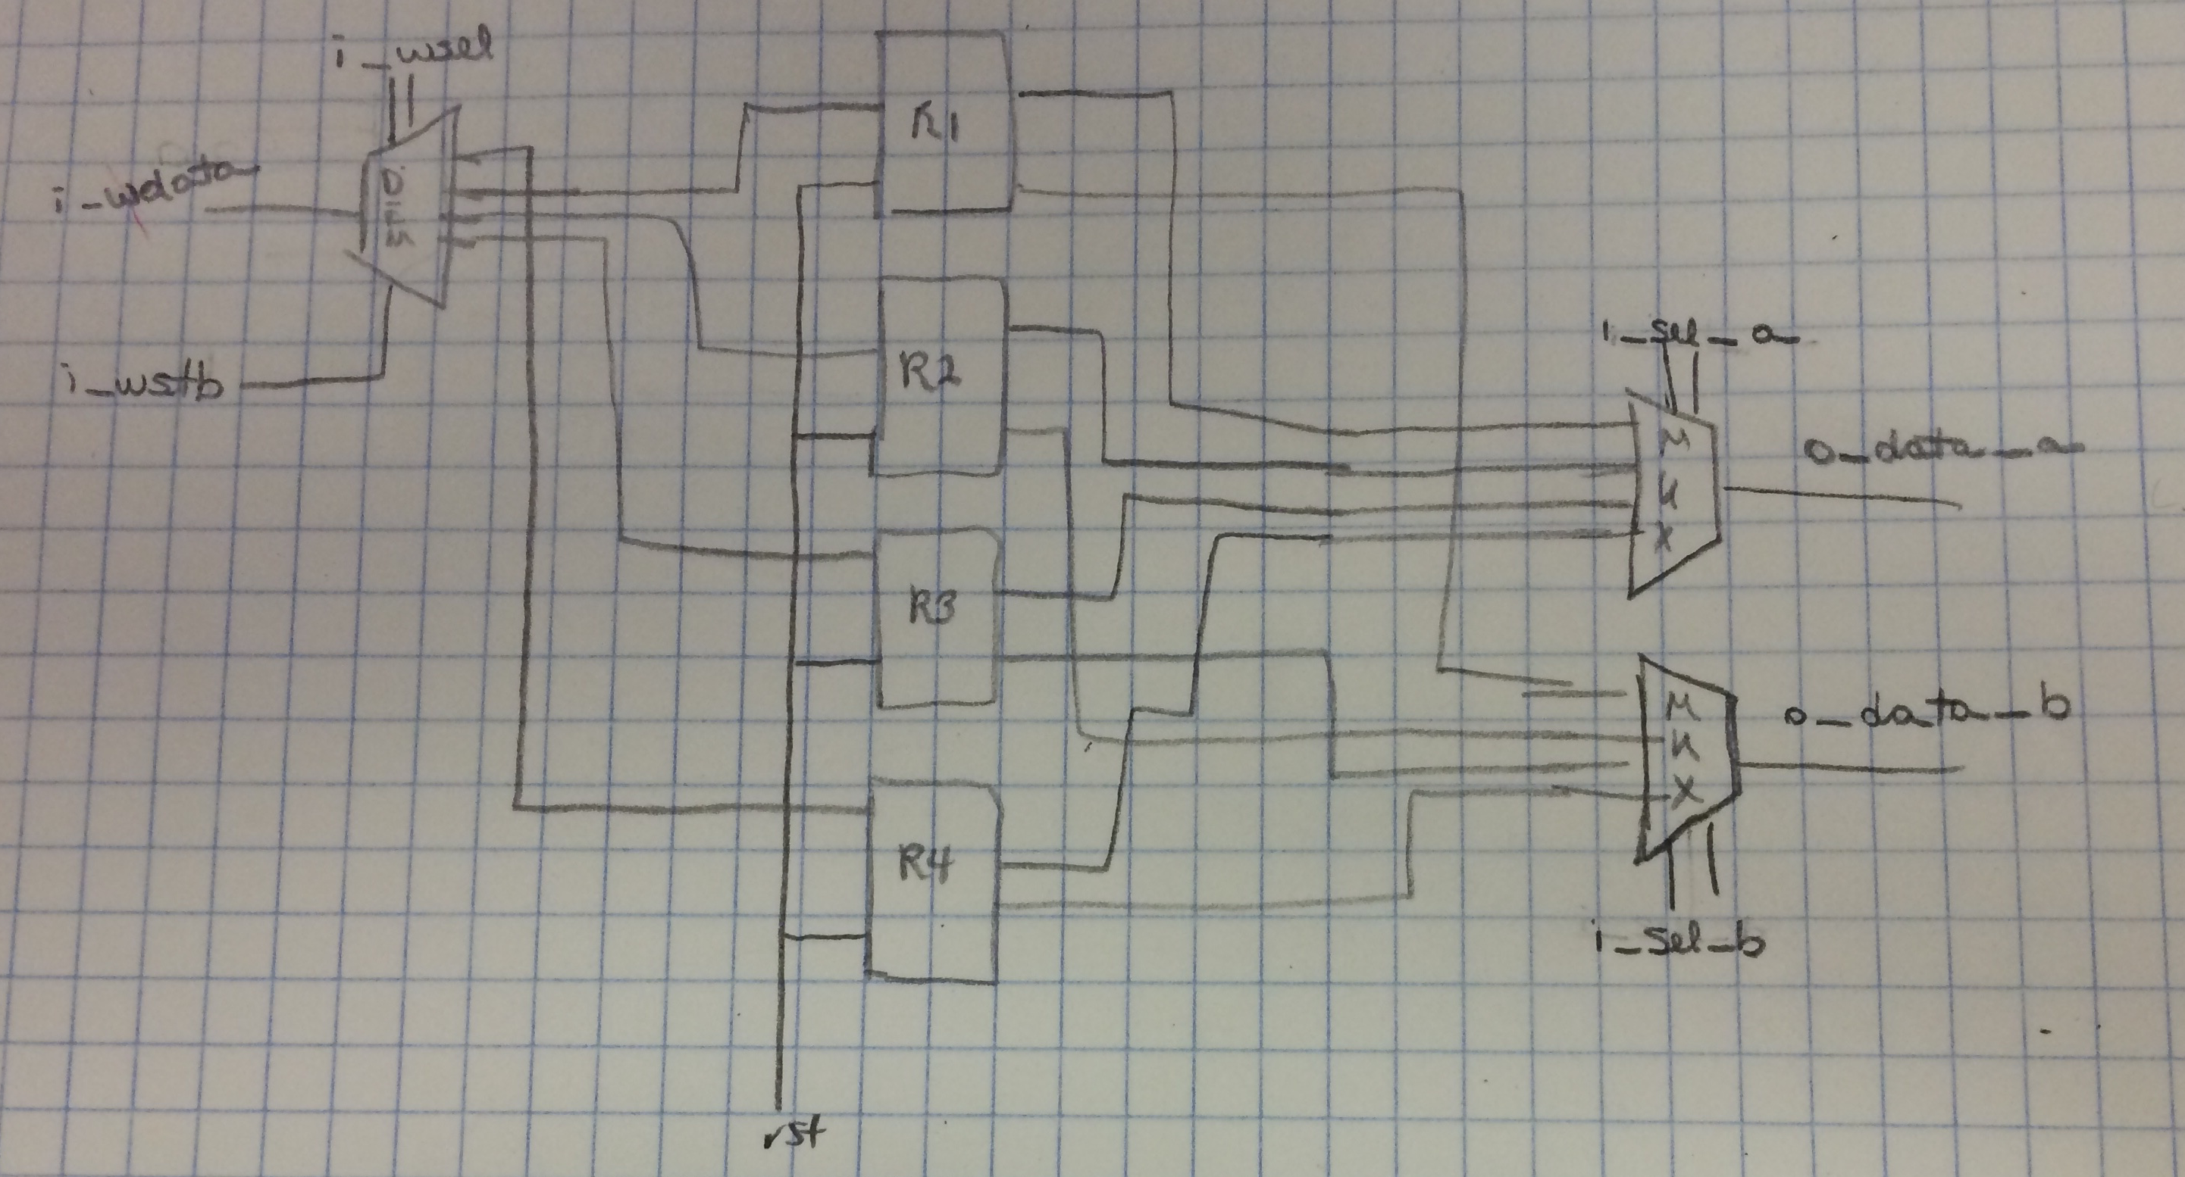

5) 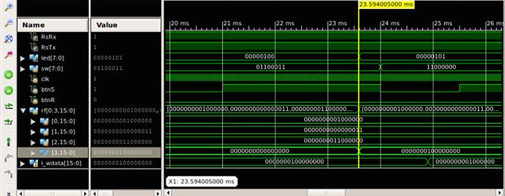

**Nicer UART Output:**

We created a 64 bit buffer to store the each byte of data. Every time data is received instead of outputting each byte, we stored the byte in the buffer by shifting the buffer to the left by a byte and storing the received data in the first 8 bits of the buffer. If the byte was a carriage return, then we display the whole buffer.

Outputs only on carriage return (model_uart.v):

// beginning of model_uart….

reg [7:0] rxData;

event evBit;

event evByte;

event evTxBit;

event evTxByte;

reg TX;

//Just added

reg [63:0] buffer = 0;

initial

begin

TX = 1'b1;

end

always @ (negedge RX)

begin

rxData[7:0] = 8'h0;

#(0.5*bittime);

repeat (8)

begin

#bittime ->evBit;

//rxData[7:0] = {rxData[6:0],RX};

rxData[7:0] = {RX,rxData[7:1]};

end

->evByte;

//store buffer and shift for more numbers

buffer = buffer << 8;

buffer[7:0] = rxData;

if(rxData == 4'h0D)

begin

$display ("This is the buffer: %s", buffer);

buffer = 0;

end

end

// rest of model_uart….

**An Easier Way to Load Sequencer Program:**

1) The instructions are sent to the UUT when the task tskRunInst is called. TskRunInst stores the instruction in sw and presses the submit button to send it to the UUT.

task tskRunInst;

input [7:0] inst;

begin

$display ("%d ... Running instruction %08b", $stime, inst);

sw = inst;

#1500000 btnS = 1;

#3000000 btnS = 0;

end

endtask //

2) tskRunPUSH, tskRunSEND, tskRunADD, and tskRunMULT are called in this process which is then sent to the UUT by tskRunInst

We modified the testbench to open the file seq.code and read the first line of the file into the integer instruction_count using $fopen and $fscanf. If the number of instructions is greater than 1023, then we set it to 1023 so that it won’t read more than 1024 lines in total. Then for the number of instructions, we read a line from the file and send it to tskRunInst.

Testbench that loads from seq.code (tb.v): (not the whole file only parts that we changed)

// beginning of testbench…

integer i;

integer data_file;

integer instruction_count;

integer captured_data;

/*AUTOWIRE*/

// Beginning of automatic wires (for undeclared instantiated-module outputs)

wire RsRx; // From model_uart0_ of model_uart.v

wire RsTx; // From uut_ of nexys3.v

wire [7:0] led; // From uut_ of nexys3.v

// End of automatics

initial

begin

clk = 0;

btnR = 1;

btnS = 0;

#1000 btnR = 0;

#1500000;

data_file = $fopen("seq.code", "r");

if(data_file == 0)

begin

$display("error in file");

$finish;

end

$fscanf(data_file, "%b\n", instruction_count);

if (instruction_count > 1023)

begin

instruction_count = 1023;

end

for (i = 0; i < instruction_count; i = i + 1)

begin

$fscanf(data_file, "%b/n", captured_data);

tskRunInst(captured_data);

end

#1000;

$finish;

end

// rest of testbench file…

**Fibonacci Numbers:**

Fibonacci.code:

11000

00000001

11000000

00010001

11010000

01000110

11100000

01100100

11000000

01001001

11010000

01000110

11100000

01011000

11000000

01100001

11010000

01000110

11100000

01011000

11000000

01100001

11010000

01000110

11100000

Output:

1501000 ... Running instruction 00000001

5243925 ... instruction 00000001 executed

5243925 ... led output changed to 00000001

6001000 ... Running instruction 11000000

9176085 ... instruction 11000000 executed

9176085 ... led output changed to 00000010

This is the buffer: 0001

10501000 ... Running instruction 00010001

14418965 ... instruction 00010001 executed

14418965 ... led output changed to 00000011

15001000 ... Running instruction 11010000

18351125 ... instruction 11010000 executed

18351125 ... led output changed to 00000100

This is the buffer: 0001

19501000 ... Running instruction 01000110

23594005 ... instruction 01000110 executed

23594005 ... led output changed to 00000101

24001000 ... Running instruction 11100000

27526165 ... instruction 11100000 executed

27526165 ... led output changed to 00000110

This is the buffer: 0002

28501000 ... Running instruction 01100100

31458325 ... instruction 01100100 executed

31458325 ... led output changed to 00000111

33001000 ... Running instruction 11000000

36701205 ... instruction 11000000 executed

36701205 ... led output changed to 00001000

This is the buffer: 0003

37501000 ... Running instruction 01001001

40633365 ... instruction 01001001 executed

40633365 ... led output changed to 00001001

42001000 ... Running instruction 11010000

45876245 ... instruction 11010000 executed

45876245 ... led output changed to 00001010

This is the buffer: 0005

46501000 ... Running instruction 01000110

49808405 ... instruction 01000110 executed

49808405 ... led output changed to 00001011

51001000 ... Running instruction 11100000

55051285 ... instruction 11100000 executed

55051285 ... led output changed to 00001100

This is the buffer: 0008

55501000 ... Running instruction 01011000

58983445 ... instruction 01011000 executed

58983445 ... led output changed to 00001101

60001000 ... Running instruction 11000000

62915605 ... instruction 11000000 executed

62915605 ... led output changed to 00001110

This is the buffer: 000D

64501000 ... Running instruction 01100001

68158485 ... instruction 01100001 executed

68158485 ... led output changed to 00001111

69001000 ... Running instruction 11010000

72090645 ... instruction 11010000 executed

72090645 ... led output changed to 00010000

This is the buffer: 0015

73501000 ... Running instruction 01000110

77333525 ... instruction 01000110 executed

77333525 ... led output changed to 00010001

78001000 ... Running instruction 11100000

81265685 ... instruction 11100000 executed

81265685 ... led output changed to 00010010

This is the buffer: 0022

82501000 ... Running instruction 01011000

86508565 ... instruction 01011000 executed

86508565 ... led output changed to 00010011

87001000 ... Running instruction 11000000

90440725 ... instruction 11000000 executed

90440725 ... led output changed to 00010100

This is the buffer: 0037

91501000 ... Running instruction 01100001

94372885 ... instruction 01100001 executed

94372885 ... led output changed to 00010101

96001000 ... Running instruction 11010000

99615765 ... instruction 11010000 executed

99615765 ... led output changed to 00010110

This is the buffer: 0059

100501000 ... Running instruction 01000110

103547925 ... instruction 01000110 executed

103547925 ... led output changed to 00010111

105001000 ... Running instruction 11100000

108790805 ... instruction 11100000 executed

108790805 ... led output changed to 00011000

This is the buffer: 0090

Stopped at time : 109502 us : File "/home/d/Desktop/M152A/lab1/tb/tb.v" Line 89

ISim>

**Conclusion:**

Through the lab, we successfully designed a sequencer using the FPGA correctly as shown by the output when we ran the simulation. We also learned how the UART and the UUT work and modified the initial source files in order to achieve the intended result in the lab. In the order to check if our code was correct, we modified the source code to output the values that the register and buffers had to make sure that it was doing the right thing; mainly for the exercise for processing binary inputs through static code and code that was read through a text file.